Name: | DoB:
Unit Number: | NHS No:
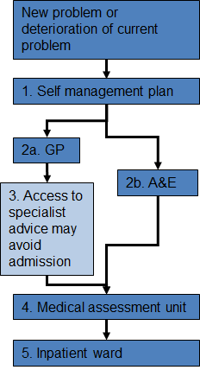 | Stage | Where will this happen? | Who will be involved? | What knowledge and skills will be needed? | How can we ensure the right information and support is available?
 | 1 | At home | Parents, carers and # | Physio therapy  Management of epilepsy  Gastrostomy feeds & care  To keep # healthy and well, by administration of all # medications and her feeds. | Training has been delivered previously by staff at Alder Hey hospital.  It is possible to access refresher training from the Carer Skills Passport Project at Alder Hey  Physiotherapy delivered and techniques shared with family.
 | 2a | At home or at GP practice | GP, parents, carer and # | Understanding of infection- recognising and diagnosing infection and prescribing appropriately  Recognise # is becoming unwell and needs to see GP. | Qualified staff will diagnose and prescribe.
 | 2b | A&E | Parents, carers, #, Ambulance crew, doctors and nurses at A&E | Possible Gastrostomy replacement/  Chest infection. Seizure control.  Recognise # is unwell and needs to access urgent care, will call an ambulance. A&E will make any diagnosis and prescribe appropriate medications, and admit # if necessary. | All knowledge, skills will be delivered by trained staff.
 | 3 | At hospital or home dependent on service | Parents/ Carers/ #/CCNT/ A&E staff/ Physiotherapists/GP | Possible Gastrostomy replacement  Change in consumables/ equipment. | All knowledge, skills will be delivered by trained staff
 | 4 | N/A | N/A | N/A | N/A
 | 5 | Alder Hey based ward- ## will be an inpatient | Parents/ Carers/ # /doctors /nurses / Physiotherapists/ LD team | Knowledge of # what # likes and does not like.  Possible mi-key replacement.  Possible seizure control management.  Possible treatment of chest infection  Treatment of any other concern #presents with. | All knowledge, skills will be delivered on ward by trained staff.

