Standard Operating Procedure (SOP)
Framework for Transitioning Complex Young People to Local Adult Community Primary Care and Acute Secondary Care Services

Contents
1 Introduction 3
1.1 Purpose 3
1.2 Scope 3
2 Abbreviations 3
3 Key Partners Involved in development 3
4 Background 4
5 Quick reference guide: 10 steps clinical transition pathway to adult services 5
6 Duties 6
7 Specific Procedure 6
8 Monitoring 9
9 Further Information 9
Appendices 9

Introduction

Purpose
The purpose of this SOP / framework is to detail the process, using the Alder Hey 10 Steps Transition Pathway, to complete a safe and seamless transition from paediatric to adult community and acute health services, for young people with complex neuro and physical disabilities.

Scope
The scope of this SOP covers young people registered with GPs within the geographical area supported by Mersey Care NHS Foundation Trust.
The principles of this SOP are equally applicable to all young people under the care of Alder Hey NHS Foundation Trust with complex neuro and physical disabilities undergoing transition from paediatric to adult community and acute health services.

Abbreviations
AHFT Alder Hey Foundation Trust
TSLN Transition Service Lead Nurse or their nominated deputy (Alder Hey NHS Foundation Trust)
CTSN Community Transition Specialist Nurse or their nominated deputy (Mersey Care NHS Foundation Trust)
SOP Standard Operating Procedure
C&YOUNG PEOPLE Children and Young People
YOUNG PEOPLE Young Person / Young People
HIP Health Information Passport
OPD Outpatient Department
ICCT Integrated Community Care Team
PCN Primary Care Network
GP General Practitioner
ACP Advanced Care Plan
AED Accident and Emergency Department

Key Partners Involved in development
  - Alder Hey Children’s Hospital – Transition Team
  - Mersey Care Foundation Trust – Transition specialist nurse, Community Physical Health Services and LD Specialist Services
  - Liverpool University Hospitals NHS Trust
  - Liverpool CCG
  - Sefton CCG
  - Liverpool City Council – Transition team
  - NHSE/I Specialised Commissioning Team

Background
What is transition to adult services?
When children become adults, it is normal for them to make decisions for themselves, and to lead a more independent life. Children’s health and care needs also change as they grow up. Transition to adult services (Transition) is the name given to the process of moving on from children’s to adult services. Some young people do not have capacity to make decisions and have complex health needs. In these circumstances the family or carers are the advocates and the voice for the young people
- This SOP is mainly concerned with Transition to Adult Community / Primary Health Services and the GP.
- The same planning process using the Alder Hey Foundation Trust (AHFT) 10 Steps Transition Pathway will be implemented, to transition the acute care needs of complex young people to adult secondary / acute care in parallel
- Some young people with more complex needs also have support from social care and special education. In this instance the Alder Hey Transition Service Lead Nurse (TSLN) will work with these services to support co-ordination of the different transitions together.
Why do we need transition to adult services?
Transition is important to ensure that services are appropriate for the age, health and care needs of young people and their families, to ensure that care is seamless throughout the life course of the individual.
What will happen during transition?
Transition is a gradual process. Young people and their families often need guidance and encouragement but shouldn’t feel rushed or unsupported. This SOP / framework sets out the duties and responsibilities that should be followed before, during and after transition.
The pathway outlines key steps in the transition pathway from paediatric community services to local adult community / primary care services
*To note: the planning for transition to the adult acute care setting will be done in parallel to community service transition planning, using the same planning process and the AHFT 10 Steps Transition Pathway
*Key stakeholders for steps 6-9 (see Appendix 1)*

Quick Reference Guide: 10 Steps Clinical Transition Pathway to Adult Services
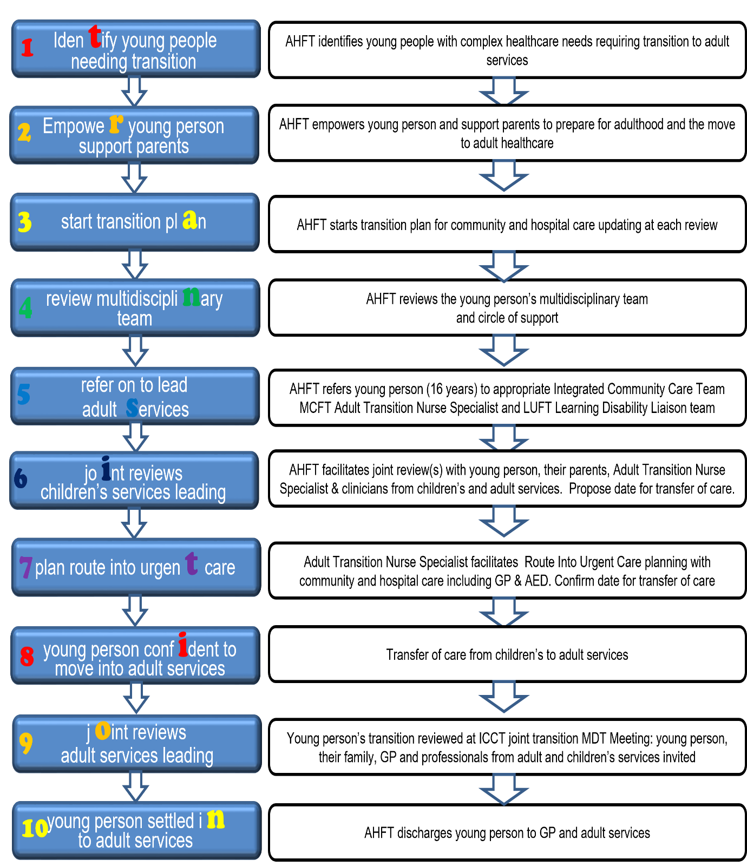

Duties
The Alder Hey Foundation Trust Transition Service Lead Nurse (TSLN) works with young people who have complex neuro-disabilities and their families, delivering non-clinical transition planning. Developing together a person-centred transition plan, Health Information Passport (HIP) and self-management plan / Route into Urgent Care Plan; to empower the Young People (where they have capacity) to manage their long-term condition and be transition ready. Whilst supporting the family/carers.
The TSLN liaises with all clinicians at AHFT including community clinicians, to coordinate and plan for a person centred, holistic transition to adult services (primary and acute care) in a safe, seamless, and timely manner.
During transition planning it will be necessary, at an appropriate time, to hold a joint meeting / MDT with the young person their family, community clinicians and the Mersey Care community transition specialist nurse, ICT Coordinator from the local community PCN (all age community health services) and the young person’s GP; to discuss and plan a date for transfer of care of the young person to adult community services.
In parallel, AHFT speciality service consultants will be planning transition for the young person to move to acute care or the GP, depending on each young person’s needs.

Specific Procedure
STEP 1- Identifying young people needing transition
- The AHFT TSLN or community teams will identify and begin conversations with young people who have complex neuro-disabilities and their families about their health needs and transition to adult services, around the time of the young person's fourteenth birthday.
- The TSLN or community teams will invite the young people and their family / carers to attend a transition planning consultation

STEP 2- Empowering young people, supporting parents/Carers
- The AHFT TSLN or community teams will work through the 10 Steps Transition Pathway with the young people and family, depending on the age and ability of the young person. This will help develop the knowledge and skills the young person will need to keep healthy and well. (Where young people do not have capacity, this will be delivered with the young person and their family as their advocates).

STEP 3 - Starting a Transition Plan
- The AHFT TSLN or community teams will work in partnership with the young person and family to create a bespoke personal Transition Plan, Health Information Passport and Route into Urgent Care plan for each young person.
- These will be tailored to the individual health needs of the young person, and co-ordinated with other aspects of Transition as necessary.
- The young person and the family will be given a copy of plans and have the opportunity to read it and ask questions.
- The Transition Plan, Health Information Passport and route into urgent care plan will be updated at each appointment.
- All plans will be shared with all professionals in the paediatric setting who care for the young person, to ensure parallel transition planning with all service specialities

STEP 4 - Reviewing the multidisciplinary team
- The Circle of Support is the group of people, professionals, friends, and family, who are there to help the young person. The AHFT TSLN or community teams will list the multidisciplinary team of professionals in each young person's Circle of Support.
- Paediatric consultants will identify appropriate services to take over each aspect of the young person’s care in the adult sector. This may be an adult consultant or the young person’s GP
- The young person’s GP will be more important in their Circle of Support after transition to Adult Services. As such the TSLN or community teams will identify the community-based transition nurse specialist, in Mersey Care adult community services who will be the young person's key care coordinator after transfer of care

Step 5 - Referral to adult services
- Consent will be gained from the young person and family for AHFT services to make referrals to professionals who will be taking over each young person’s care in the adult sector
- For complex young people who require interventions in the home setting to stay healthy and prevent avoidable hospital admission; the Alder Hey TSLN or community teams will make a referral to the Mersey Care transition nurse specialist. The Mersey Care transition nurse specialist will liaise with the local Integrated Community Care Team coordinator in the Primary Care Network local to the young person’s home, for future planning and to plan handover of care
- The Mersey Care transition nurse specialist will be invited to joint transition planning consultations, to meet the young person and family, and start to plan services that may be required after transfer of care
- Where possible the young person will be offered a choice of acute / secondary care services, where practicable.
- For young people with a Primary Healthcare Need the young person's care package will transition from Continuing Care (CC) to Continuing Healthcare (CHC) when the young person is 18, and as such plans will need to be refined / adjusted in line with the change in support from statutory providers.
- AHFT Consultants will in parallel make referrals to adult specialist services or the GP as appropriate; inviting adult services to a joint consultation led by paediatric services at AHFT

STEP 6 – Joint reviews: children’s services leading
- The AHFT TSLN and community teams will invite the young person and their family to attend a Transition planning consultation, led by the AHFT teams, inviting the Mersey Care transition nurse specialist
- This will allow the young person and the family meet Mersey Care transition nurse specialist who will be supporting their care, and give the opportunity to advise the young person and family of their service offer, and start to plan services that may be required after transfer of care
- AHFT teams will ask the young person and families’ permission to share a full electronic copy of the young person’s health transition records with Mersey Care transition nurse specialist and community services, and offer the young person and family a copy also
- Transition 'workshops' / events to be planned for families to attend and understand changes.

STEP 7 - Planning the route into urgent (emergency) care
- The route into urgent care will be discussed with the young person and family as part of the joint Transition planning consultations
- In the event the young person deteriorates at home the family will contact the GP and the appropriate care will be directed by the current care plan aligned to the young person, and specific needs or emergency services as appropriate
- In the event of an emergency that cannot be managed safely by the GP the family will call 999.
- AHFT teams will ensure the young person’s GP, Mersey Care community-based transition specialist nurse and local community adult services have the necessary information to support the young person if the young person’s condition deteriorates
- The Mersey Care community-based transition nurse specialist will facilitate route into urgent care planning with community and hospital care including the GP & AED. A date for transfer of care will be confirmed
- Once the young person has moved into adult health services, they will not be taken to Alder Hey if an ambulance is called, or they need to go into hospital.
- The AHFT teams will ensure the young person and family know which hospital they are likely to be taken to, and that those adult teams have the necessary information to support the young person.

STEP 8 - Moving into adult services
- Eventually the young person will be ready to attend adult consultations or be admitted to an adult hospital ward, and care will be transferred to adult services.
- At this time, in parallel the young person ‘s community care needs will be handed over to the Mersey Care community-based transition nurse specialist and local adult community health services.
- The young person will have comprehensive transition plans, including Advance Care Plans for those under palliative care
- With the delivery of good transition planning, each young person and their family will feel confident and ready to make the transfer to adult services
- Most complex young people and their families will be transition ready and will move into adult services when they are approximately 17-18 years old.
STEP 9 - Joint reviews: adult services leading
- The Mersey Care transition nurse specialist and the ICT coordinator will convene a joint transition MDT meeting, inviting the young person, their family, the young person’s GP and professionals from adult and children’s services, including the acute learning disability nurses from adult acute care
- Formal handover/transfer of care will happen at this joint meeting
- Children’s community services will be available to provide advice and support to professionals in adult community services for a while after transfer of care.
- Adult acute care can invite a paediatric AHFT team member to attend a joint review led by adult services, to support the young person and family with their first adult consultation
STEP 10 - Settling into adult services
- At around the young person’s 18th birthday, the young person and their family will feel confident and well supported with local adult services, at this time AHFT will formally discharge the young person from children’s services.

Monitoring
The initial SOP / Framework will be worked up and developed as part of the Transition working group to develop the respective ‘offer’ within the community aligning with colleagues across the health and care spectrum.
(The provider may wish to add ‘formal’ monitoring and agreement governance).
Monitoring | Lead Responsible | Frequency | Responsible Committee
To be reviewed annually | Transition leads from AHFT: LUFT & MCFT | Annually | Transition of complex young people operation group

Further Information
CQC (2014) From the pond into the sea- Children’s transition to adult services: https://www.cqc.org.uk/sites/default/files/CQC_Transition%20Report.pdf
Department of Health - (2006) Transition- Getting it right for young people: Improving the transition of young people with long term conditions from children’s to adults’ health services: https://dera.ioe.ac.uk/8742/2/A9R93BB_Redacted.pdf

NICE NG43 Guidelines (2016) Transition from children’s to adult services for young people using health or social care services. https://www.nice.org.uk/guidance/NG43/chapter/recommendations

Appendix 1
Key stakeholders for step 6-9 and guidance for planning
- ICT Coordinator- Integrated Community Care Coordinator- (Coordination of MDT)
- GP
- AHFT TSLN
- AHFT lead Consultant
- Mersey Care Community Transition nurse specialist (MCFT)
- LD nurses LUFT
- Community paediatrician
- SENCO lead at school
- School Nurse
- Social worker
- OT – (if in circle of support / multi-disciplinary team)
- Dietician - (if in circle of support / multi-disciplinary team)
- Burdett Transition Nurse- (If YOUNG PEOPLE attend Redbridge school)
This list is not exhaustive - and each MDT will be personal to each YOUNG PEOPLE
Reviewing what is delivered at community level e.g., by GP District Nurses / matrons, physiotherapists etc. The criteria and support needed if YOUNG PEOPLE is admitted via urgent care e.g., community services in-reaching to support timely discharge, use of health information passports.

Appendix 2

Integrated Care Team (ICT) Multi-Disciplinary Meeting for Young people who are transitioning to Adult Care Services

Criteria for referral:

- Young person who is 16 years or over.
- Requires care from community health services.
- Is registered with a Liverpool or Sefton GP.
- Is able to consent to discussion or has a parent or carer who can consent on their behalf.
- Have multiple health needs which require an integrated approach.
- Does not require urgent care or has a primary need which is best met by acute services.

Successful transition aims to ensure engagement and empowerment through a coordinated strategic approach. The ultimate goal is that young people and where appropriate their family/ carers have control of their condition and are able to make choices that will enable them to achieve the best possible state of health and psychological wellbeing.
There should be a clear process for transferring care for young people to adult services, between providers and between primary, secondary and tertiary care and across specialities in the case of young people with complex needs.
Purpose of a Multi-Disciplinary Team (MDT) for young people with Multiple Needs:
Unlike other Integrated Care Team MDT’s, the MDT for young people with multiple needs is non-Primary Care Network Specific and is a city-wide resource, accepting referrals according to need and complexity rather than geographical boundaries.

The key aims of the MDT are:
- To bring together all the relevant people and agencies in order to assess, plan and co-ordinate the best way to meet the needs of the young person.
- To work collaboratively to provide a joined up single plan for service delivery for each person, their family and carers.
- To ensure the co-produced plan establishes clear aims and objectives and clarifies the role of each person / agency in terms of delivery and support.
- To support the young person’s GP or Lead Clinician by coordinating discussion and care planning through the ICT Coordinator.
- To ensure a psychologically informed approach – building meaningful working relationships that understand health and lifestyle, address need and facilitate and promote change, using an asset based approach to care which maximises social and cultural capital.
- To maximise the use of multi-agency resources and ensure more comprehensive care and support provision for young people.
- To fully involve the young person in the discussion and decisions about their support and care plans.
- To fully involve the family / carers (where appropriate) in the discussion and decision about their family members support and care plans.
- To share information to increase the safety, health, and well-being of the young person with multiple needs and whose needs are best met through an integrated approach which requires input from multiple professionals, disciplines and agencies.
- To reduce the likelihood of need for admission to hospital.
- To improve the experience of care for the young person and their family.
A dedicated MDT for young people with multiple needs enables services to provide a more effective pathway for transition from child to adult services which reduces need for acute admission, improves outcomes and patient experience.
Referral to the MDT
A referral should be made to the ICT MDT when standard service options are not meeting the needs of the young person and this is a barrier to transition. A referral to the MDT should be made by the Lead Clinician in the young person’s care; this may be the GP or another health professional.
The young person’s views, preferences and needs will inform the decision-making process from referral onwards.
The decision-making process results in clear recommendations on the treatment/care plan resulting from the meeting.
These recommendations are:
- Evidence-based (e.g. in line with NICE guidelines);
- Person-centred (in line with young person’s views & preferences when known and taking into account multiple needs);
- In line with standard service protocols unless there is a good reason against this, which should then be documented.
Referrals are made to the MDT administrator and Care Coordinator via EMIS or secure email
All referrers must complete a referral form with agreed minimum data set information, including needs and risk assessment and where EMIS is available to the referrer the EMIS ICT referral form should be used. The referrer or their representative must be present at the MDT when the client is discussed.
The responsibility for case management and on-going actions remains the responsibility of the referrer unless otherwise agreed in the MDT. The Integrated Care Team MDT does not hold a caseload as it is a forum for discussion and shared action allocation rather than a case management facility.
The MDT meets bi-weekly on various days dependent on locality (Monday to Friday 9-5) to consider agreed referrals and provide follow-up reviews for existing clients, thereby providing a planned, central point of contact for decision making; all members have the option of attendance via TEAMS.
The Young Persons MDT Members
Although attendance at an MDT is flexible to meet the needs of the person being assessed, the Young Person MDT is likely to comprise of representatives from the following agencies:
- Learning disability services
- Social Services – Social Worker
- Primary Care/GP – where the young person is registered with
- Parent or carer
- Secondary Physical Health Services: respiratory, neurology, gastroenterology
- Community Health Services relevant to the needs of the young person: community paediatricians, district nurse, community matron and community therapists
- Children’s community matron and or Paediatric Transition lead nurse
- ICT Team
These agencies are focused on the needs of the young person who has multiple, and in some cases, complex needs and therefore representation within the meeting differs from that within the other Integrated Care Team MDT’s which are already well established.
Representatives attending the MDT should have the authority to offer the resources required in order to be able to make decisions about service provision on behalf of their organisation. The aim of the MDT is to find solutions for young people who need a proactive approach to support their transition to adult care. Partners, therefore, must be willing to think creatively and work flexibly to look at the young person and their needs in an integrated way.
Any relevant, specific or high-risk discussions will be recorded on EMIS by the Integrated Care Team where appropriate, in a contemporaneous manner.

Document Control Sheet
Framework for Transitioning Complex Young People to Local Adult Community Primary Care and Acute Secondary Care Services
Version: | 1
Ratified by: | Community & Mental Health Division Policies and Procedures Sub-Group
Date ratified: | 05/04/2022
Name of originator/author: | Jacqui Rogers
Approved by: | ‘Operational’ Planning the transition of complex young people to adult services Alder Hey, Mersey Care, LUFT  LHCH Respiratory / Oxygen team  Commissioners - Liverpool & Sefton
Date approved: | 22/02/2022
Date issued: | May 2022
Review date: | May 2025

Version Control Table
Version | Date | Author | Status | Comment
1 | May 2022 | Jacqui Rogers | Current
0.8 | 22/02/2022 | Mersey Care (MC)  Trish Mattinson & Katie Taylor | Draft | Amendments to fit into MC community structures & MDT schedules
0.7 | 20/05/2021 | Mersey Care (MC)  Pat McGuiness & Trish Mattinson | Draft | Amendments to fit into MC community structures
0.6 | 21/01/2021 | Lynda Brook | Draft | Addition of logos, revised diagram, clarification of scope, abbreviations to include individual or their nominated deputy, formatting
0.5 | 26/11/2020 | Lynda Brook /  Lisa Cooper | Draft
0.4 | 25/11/2020 | Jacqui Rogers | Draft | Amendments from Lynda Brook
0.3 | 15/09/2020 | Jacqui Rogers | Draft | Amendments from Lisa Cooper and Josette Niyokindi
0.2 | 11/09/2020 | Alison Brook | Draft | Amendments to original version
0.1 | 16/08/2020 | Jacqui Rogers | Draft | New SOP; no previous version

Review & Amendment Log

Record of changes made to document since last approved version
Section Number | Page Number | Change/s made | Reason for change

